BRANDOPS SIMULATOR
Student Rulebook & Field Guide
Multimedia Marketing · Semester-Long Simulation
Welcome to BrandOps.

You are now the leadership team of a real brand. You'll face economic crises, social media firestorms, competitor attacks, and your own creative deliverables — all while your stats, stock price, and market ranking update in real time.

This isn't a class project. It's a simulation. Make smart decisions, produce great work, and your brand thrives. Make bad ones, and the market will let you know.

1. The Big Picture
BrandOps runs for 18 weeks across 6 phases. Each week, your team will:
- Complete a creative deliverable — your actual multimedia project for the week
- Respond to market events that affect your brand's five stats
- Post to BuzzNet — the simulation's live social feed (2 posts per week)
- Write a weekly journal entry reflecting on your creative decisions
- Track your brand's performance on the live leaderboard

At the end of each phase, your team writes a Shareholder Letter — a formal reflection addressed to your investors, summarizing what happened and what comes next.

Your teacher controls the simulation from a Teacher Console. You track your brand from your personal Brand Dashboard — a live page with your stats, stock price, event history, score log, and BuzzNet composer.

2. Your Brand Dossier
At the start of the simulation, every team receives a Brand Dossier — a profile that defines who you are. Brand Name, Industry, Country, and Target Demo are the four fields that actually drive game mechanics. Components and Price Point are flavor — they’re part of your brand’s story but don’t directly affect your stats.

DOSSIER FIELD | WHAT IT MEANS
Brand Name | Your company's name. Own it.
Industry | The market you compete in — e.g. Athletic Wear, Gaming, Luxury Fashion.
Country of Origin | Where your brand was founded. Affects supply chain events.
Target Demo | Your core customer — Gen Z, Athletes, Eco-Conscious Consumers, etc. Everything you create should speak to them.
Components | Budget / Standard / Premium — part of your brand's backstory and flavor.
Price Point | Economy / Mid-Range / Premium / Luxury — part of your brand's backstory and flavor.

3. Your Brand Identity
From day one, your Brand Dashboard lets you set three things that define how your brand appears everywhere in the simulation — on BuzzNet, the leaderboard, and the class display screen.

IDENTITY ELEMENT | HOW TO SET IT
Logo | Upload a PNG or SVG to a free image host (Imgur or Google Photos), paste the direct link into the Logo URL field, and click Save Identity. Your logo appears in the top bar of your Brand Dashboard and on every BuzzNet post you make.
Tagline | A short slogan — 60 characters max. Shows under your handle on BuzzNet posts.
Brand Color | Pick a hex color using the color picker. It becomes the accent stripe on your BuzzNet posts.

⚠ Logo Requirement
Your Logo & Visual Identity deliverable must be submitted in vector format (.AI or .SVG, created in Adobe Illustrator or Affinity Designer). The PNG or JPG you upload to your Brand Dashboard is your display version — the vector file is your graded submission.

4. Your Five Stats
Your brand is tracked across five core stats. Every stat is a number from 0 to 100. Your goal is to keep the right ones high — and one of them low.

STAT | WHAT IT MEASURES | HIGH IS… | LOW IS…
Budget | Your available money to spend on campaigns, responses, and upgrades. | ▲ More resources | ▼ Emergency mode
Demand | How much consumers want your product right now. | ▲ Sales are strong | ▼ Sales collapsing
Reputation | How the public and press perceive your brand. | ▲ Trusted brand | ▼ PR crisis mode
Innovation | Your product's quality, tech edge, and forward-thinking. | ▲ Market leader | ▼ Falling behind
Risk | Regulatory exposure, safety issues, PR vulnerability. LOWER IS BETTER. | ▲ Crisis imminent | ▼ Safe & stable

⚠ Risk is the exception — you WANT it low.
Every other stat you want as high as possible. Risk is the opposite. If Risk hits 100, a mandatory Crisis Event triggers automatically.

5. Market Score & Stock Price

Market Score
Your Market Score is calculated automatically from your stats:

Market Score = Demand + Reputation + Innovation + (Budget ÷ 10) − Risk

This is your primary ranking on the leaderboard. The team with the highest Market Score at the end of Week 18 wins the season.

Stock Price
Your brand also has a stock price that updates regularly. It's based on your Market Score plus a small random drift — which gets bigger when Market Volatility is high. The stock ticker scrolls across the top of the class display screen in real time.

Think of your stock price as a public mirror of your decisions. Strong creative work and smart event responses push it up. Crises and poor execution drag it down.

6. Event Cards
Each week, your teacher may draw an Event Card that affects your brand. There are four decks:

DECK | WHAT HAPPENS
Economic | Tariffs, supply chain collapses, recessions, investor funding. Hits your Budget and Demand.
Social | Influencer scandals, viral moments, boycotts, celebrity endorsements. Hits your Reputation and Demand.
Innovation | Competitor tech leaps, data breaches, R&D breakthroughs, product recalls. Hits your Innovation and Risk.
Wildcard | Anything goes. Natural disasters, congressional hearings, Olympics sponsorships, hostile takeovers.

Choice Events
Many event cards come with a choice — Option A or Option B. Each option has different stat consequences. Your teacher enters the choice based on your deliverable that week. This means your creative work has real consequences in the game.

Example: Influencer Scandal
Your brand's influencer partner was caught in a viral controversy.

Choice A: Cut ties publicly and fast → Reputation +8, Budget −5
Choice B: Stand by them — show loyalty → Reputation −8, Demand +5

Your crisis response commercial that week determines which path your teacher selects.

Market Volatility
Your teacher sets a Market Volatility level (0–100) that controls how wild the simulation gets:
- 0–30 — Stable market. Normal weeks, smaller swings.
- 31–70 — Active market. More events, bigger effects.
- 71–100 — Chaos mode. Massive hits and massive boosts. Wildcards appear more often.

7. How Your Work Gets Scored
Every deliverable you create is scored by your teacher on a three-level scale. That score directly changes your stats:

LEVEL | POINTS | STAT BOOST | WHAT IT MEANS
1 — Below Basic | +1 pt | +4 to affected stats | Didn't meet expectations. Minimal improvement.
3 — Proficient | +3 pts | +8 to affected stats | Met expectations. Solid stat gains.
5 — Advanced | +5 pts | +12 to affected stats | Exceeded expectations. Strong stat surge.

Each deliverable type affects different stats. A Logo & Visual Identity boosts Reputation and Innovation. A Crisis Response Ad improves Reputation and lowers Risk. A Super Bowl Commercial pumps Demand, Reputation, and Budget.

See the separate Deliverable Checklist document for the full schedule — all 15 deliverables, stats affected, rubric criteria, journal entries, and shareholder letters.

8. The Six Phases
The semester is divided into six phases. Each phase has a theme, a set of deliverables, and increasingly high stakes.

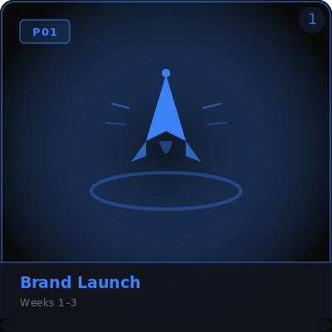  Phase 1  Weeks 1–3 | New Brands Enter the Market  Establish your brand identity and make your first impression. The choices you make here set the foundation for everything that follows. Your deliverables define who you are to the market.
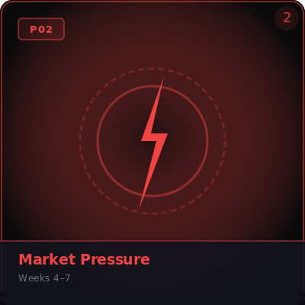  Phase 2  Weeks 4–7 | The Real World Arrives  Crises hit, competitors emerge, and volatility increases. How you handle adversity defines your brand more than how you perform in calm conditions. A great crisis response can actually boost your reputation above pre-crisis levels.
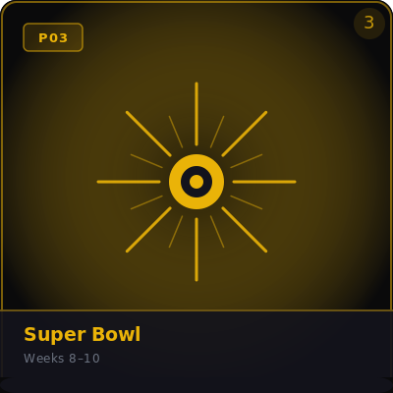  Phase 3  Weeks 8–10 | The Biggest Stage in Advertising  Super Bowl week. One commercial, 100 million people, one shot. Mass media demands a completely different kind of thinking — emotional storytelling over product specs. Spectacle over information.
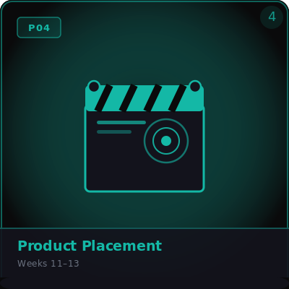  Phase 4  Weeks 11–13 | Making the Invisible Sell  Product placement. Unlike a commercial — where audiences know they're being sold to — great product placement operates below conscious resistance. The brand becomes part of the story, not an interruption to it.
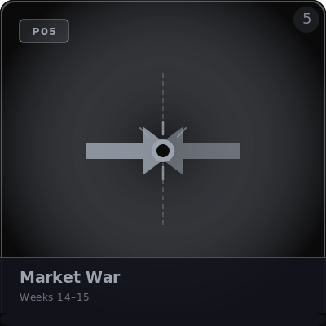  Phase 5  Weeks 14–15 | Only the Strongest Survive  Market War. The gloves are off. Four months of data have revealed who is strong, who is struggling, and where the vulnerabilities are. Comparative advertising is now on the table — use it wisely.
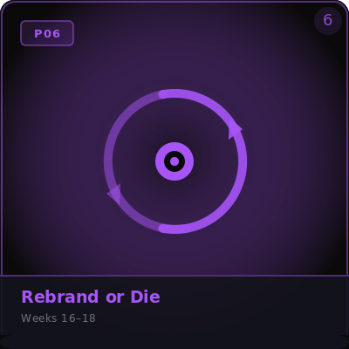  Phase 6  Weeks 16–18 | Nothing Lasts Forever  A terminal event has hit your brand. The identity you built is now a liability. Rebuild from scratch. The Investor Pitch Deck is your final deliverable — make the case that your brand deserves a second chapter.

At the end of each phase, your team writes a Shareholder Letter — a formal memo addressed to your investors. It's a reflection on what happened, the decisions you made, and your strategy going into the next phase. Your teacher provides a prompt for each one.

9. BuzzNet
BuzzNet is the simulation's live social media feed. Every team, plus simulated media accounts, rivals, and influencers, posts here throughout the season. It scrolls on the class display screen in real time.

Posting as Your Brand
You can post to BuzzNet from your Brand Dashboard — the tab labeled “📣 BuzzNet.” You get up to 2 brand posts per week. Use them strategically.

- Write in your brand's voice — speak to your target demographic
- Use hashtags and @mentions to engage with other brands
- Attach an image URL (1200×628px works best — landscape or square)
- Your logo and brand color appear on every post automatically once you've saved your Brand Identity

📸 Social Media Pivot Plan — Photography Requirement
Your Social Media Pivot Plan deliverable must include at least one original photograph taken by you (not stock imagery). Your rubric includes a photography criterion scored on DA&D Standard 4.

How Likes Work
Every post gets a randomized like count when published, scaled to simulate real audience engagement. Posts during high-volatility weeks tend to perform more extremely — either very high or very low. You can't control likes, but you can control the quality and consistency of your messaging.

10. Journal Entries
Each week your Brand Dashboard shows a journal prompt — a reflection question tied to that week's events and deliverables. Your teacher will tell you how journal entries are submitted and graded.

Prompts get harder as the season progresses. Early weeks ask you to define your brand. Later weeks push you to analyze your decisions, defend your creative choices, and reckon with what the market did to you.

Sample prompts across the season:
- Week 2: How does your visual identity reflect your target demographic? What would your customer think seeing your logo for the first time?
- Week 8: What emotion do you want the audience to feel 10 seconds after your commercial ends? Why that emotion?
- Week 15: Is comparative advertising effective, ethical, both, or neither? Use your own campaign as evidence.
- Week 18: If you could go back to Week 1 knowing everything you know now — what would you do differently, and what would you keep exactly the same?

11. The Brand Bulletin
Each team has a Brand Bulletin — a printable newspaper-style report that updates automatically from your live stats. It includes your current Market Score and ranking, all five stat bars, stock price and trend, your recent event history, and your deliverable score log.

It's a running record of your brand's full journey through the simulation and a portfolio piece you can keep at the end of the semester.

12. How to Win
The team with the highest cumulative Market Score at the end of Week 18 wins the season. But there are multiple ways to stand out:

AWARD | HOW TO WIN IT
🏆 Season Winner | Highest Market Score at end of Week 18.
📈 Stock Champion | Highest stock price at end of the season.
🎨 Creative MVP | Highest total deliverable points across all phases.
🛡 Most Resilient Brand | Lowest average Risk score across the season.
🔥 Best Comeback | Biggest Market Score recovery after hitting a low point.

13. Quick Reference Cheat Sheet

✔ THINGS THAT HELP YOUR BRAND | ✘ THINGS THAT HURT YOUR BRAND
• Score Advanced (5) on deliverables  • Choose smart event responses  • Stay consistent with your brand identity  • Keep Risk low with proactive decisions  • Justify your creative choices clearly  • Post to BuzzNet consistently (2x/week)  • Set your logo, tagline, and brand color early | • Score Below Basic (1) on deliverables  • Ignore event consequences  • Let Risk build up without responding  • Make choices that contradict your brand  • Miss deliverables entirely  • Submit logos as raster files (must be .AI/.SVG)  • Use stock photos for social deliverables

The Golden Rule

Your creative work IS your gameplay. Every poster, commercial, pitch, and campaign you produce gets translated into real stat changes. The better the work, the stronger your brand. There are no shortcuts.

14. Glossary

TERM | DEFINITION
Market Score | Your overall brand strength calculated from all five stats. Used to rank teams on the leaderboard.
Stock Price | A regularly-updated dollar value reflecting your Market Score plus small random market drift.
Volatility | A 0–100 setting that controls how extreme event effects are and how often Wildcards appear.
Brand Dossier | Your team's fixed brand profile — industry, country, demographic, components, price point.
Brand Identity | Your logo, tagline, and brand color. Set from your Brand Dashboard. Appears on BuzzNet and the leaderboard.
Event Card | A real-world scenario drawn by the teacher that changes your stats, sometimes with a choice attached.
Choice Event | An event card with two options (A/B). Your teacher picks based on your deliverable that week.
Deliverable | Your actual creative project for the week — a commercial, logo, pitch, etc.
BuzzNet | The simulation's live social media feed. You get 2 brand posts per week from your Brand Dashboard.
Journal Entry | A weekly reflection prompt tied to that week's events. Found in your Brand Dashboard.
Shareholder Letter | A formal investor memo written at the end of each phase. Reflects on decisions, crises, and strategy going forward.
Brand Bulletin | Your auto-generated newspaper report showing your full brand stats, stock history, and event log.
Brand Dashboard | Your personal student view. Access it via the link your teacher shares. Shows all stats, tabs, and BuzzNet composer.
Crisis Mode | Triggered when Risk hits 100 or Budget hits 0. A mandatory bad event fires automatically.
Phase | One of six story arcs in the semester, each with its own theme and deliverable set.

Good luck. Build something worth talking about.

